Themba Ntuli

Ironguard-Prestigious Timepiece [Madiba Dr, Mbombela 1200]

**PART1: Business Proposal**

**ST10227479-ThembaNtuli-WEDE520**

Contents

PROJECT GOAL 1

Objective overview 2

Homepage 2

The Logo 2

The Background Image 2

Target Audience 3

About Us 3

Service Page 5

Contact Us 6

# PROJECT GOAL

I have created a website for this establishment because it is (Small) business that has been in the market for some time and have now ventured in a new horizon of innovation and technology “Digital Marketing “. For many years they were a front foot business selling and conducting ,issues they had was you had to make an appointments or arrangement as you would be far to reach their location, So after years of research and study I have decided to create a website where it will be easy for customers and clients to engage with Suppliers and also buy and learn more about the products they are interested in. As a Watch dealer it was crucial for Iron-guard’s Prestigious Timepiece to be in the front line of this innovation as the watch dealers’ market is on the rise and more and more people see the value and potential in owning a timepiece is these days. As this website will focus on the kinds of brands mostly work for the business such as Rolex, Cartier …… these are the best-selling brand that people love and would go for. The aim of this is to boost sales especially around the local area in Mbombela as it is a town where the rise of riches sprouts out and more individuals want to know more about luxury timepieces.

# Objective overview

## IRON-GUARD’S PRESTIGIOUS TIMEPIECE

This is the name of the famous brand store, found in the east side of the country (South Africa) in Mpumalanga ‘The place of the rising sun’ province. In the capital city of Mbombela Nelspruit, where it was born. The name symbolises the iron steel craftmanship and how the beautiful art is laid upon your wriest and it formally came as a dream and passion to offer not just luxury watches, but timeless value. I wanted a name that will reflect the essence of power and luxury in watches such as, Strength, leadership, precision, and elegance. Iron guard Prestigious Timepiece (IPT) sells timeless top tier brand watches from luxury to entry level watches, they formalise themselves as a Vintage wealth prestige group that makes them elite in the game of watches.

## History

Iron guard Prestigious Timepiece was established by an inspiration of the first ever watch gifted to me on a birthday, this was the first time being amazed by a wristwatch. This is where the love began and research and study all formed and later had the ability to get my first Rolex Daytona “(launched in 1963, the Cosmography Daytona has long since transcended its status in the world of watchmaking to become an icon)”. This timepiece became the birth of the establishment in 2001 where the first trade was made when I went to a watch collector auction house and bid for a Cartier and sold it to make a start-up market. The Rolex watch was the foundation of the love of watches, the aura and discipline it had on the kind of people that owned it and made me very thrilled and eager to learn why and what makes the brand this expensive.

# Homepage

On the website homepage, there is an astonishing visually appealing layout of an image in the background. Then there is a fixed navigation bar, that will help the users to navigate different sections or pages. It will appear at the top of the webpage which will contain links to important pages such as Home; About us; Service; Contact us. The logo will be on the top left side of the website, there will be a welcoming message at the centre of the page. Followed by the header that will remain constant throughout all the other pages.

The design is elegant and rich in contrast, featuring a footer with copyright information. The brand’s purpose and affordability of the luxury products will follow.

# The Logo

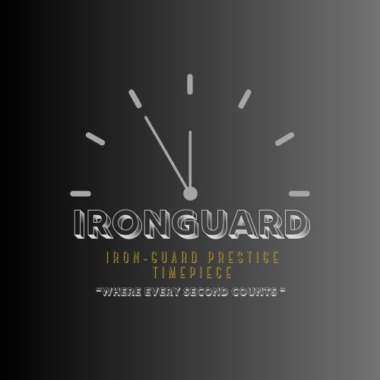

Canva

The logo is made of elements of the brand representatives, which consist of a clock and the first name of the business (Ironguard) and has the full name and slogan of the business at the lower part of the logo. There is a hour and minutes hand on the clock that symbols the meaning and elegance of the business which gives the prestigious look of classy appearance to the buyers/clients.

# The Background Image

in the background will be a vintage timepiece on the beach sand, this will symbolise how precious time is as it waits for no man. The colour is a dusty gold and is engraved in the sand with accessories and astonishing pieces of art that makes the image rich.

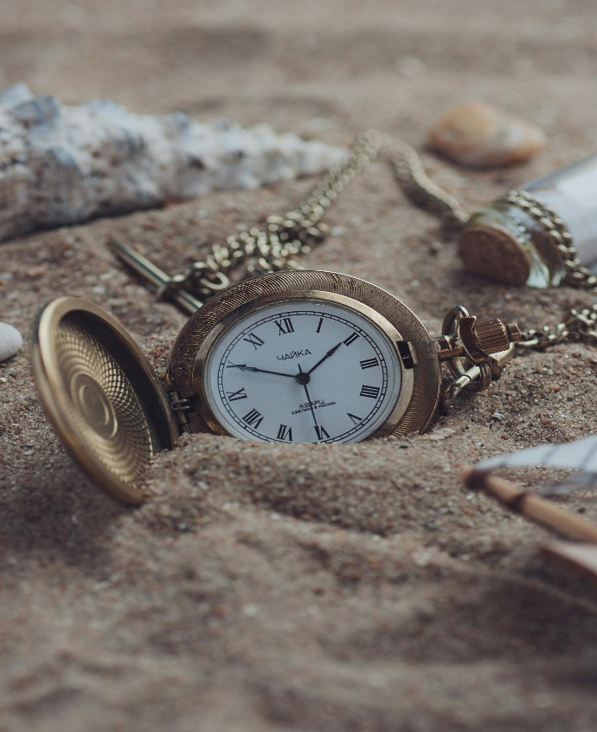

valeriia Harbuz 2

# Target Audience

Iron-guard caters to a diverse range of luxury watch enthusiasts, encompassing both younger, budget-aware collectors and affluent individuals. Our primary target demographics include:

1. Affluent Collectors & Elites - Wealthy individuals seeking handcrafted luxury items, limited editions, and a sense of exclusivity. (Sotheby, 2025)

2. Millennials & Gen Z Consumers - Tech-savvy and environmentally conscious individuals who prioritize digital authentication, customization, and ethical manufacturing practices. (Bain & Company’s Gen Z/Millennial luxury market projections 6(https://www.jewelsbylove.com/blog/post/watch-market-2025-outlook.html)., 2025)

3. Women & Gender-Neutral Buyers - An expanding market segment drawn to gender-inclusive designs and aesthetically pleasing, smaller watch styles. (CFI.CO, 2025)

## Our Mission statement

We committed to transforming the watchmaking industry through the incorporation of sustainability, innovation, and craftsmanship. Our aim is to set new standards within the sector by purchasing/ reselling timepieces that serve as both enduring investments and artistic masterpieces.

Innovation: By challenging the boundaries of watch design and technology, we ensure that each timepiece achieves a perfect balance between tradition and modernity. Our continuous investment in research and development allows us to stay at the forefront of the industry, delivering unparalleled creativity and accuracy.

Craftsmanship and Quality: Excellence is the foundation of our endeavours. Our timepieces are tailored for collectors who appreciate individuality, elegance, and timeless value. We remain steadfast in our commitment to uphold the highest standards in market as we continue to grow.

Sustainability: We advocate for a luxurious lifestyle that is mindful of its impact. Our commitment to sustainability drives us to minimize our ecological footprint and adopt ethical sourcing and manufacturing practices. By prioritizing eco-friendly materials and renewable energy, we ensure that our legacy is both distinguished and sustainable. (AG, 2025)

## Vision statement

We integrate innovation, sustainability, and skilled craftsmanship to produce luxury timepieces that respect tradition while looking towards the future.

Innovate: Incorporate technologies such as recycled metals and lab-created gemstones to restore broken pieces.

Craft: Focus on meticulous hand-finishing and timeless aesthetics. By 2030, our goal is to be recognized among the leading watch dealer and seller globally demonstrating that luxury can be both daring and responsible. Timeless, yet always forward-thinking. This is the Iron guard philosophy. (AG, 2025)

## Budget

Brand Identity - Human Touch Telling your story, much like when you make a custom suit. We'll establish your visual language (colours, typefaces, and logo) to emulate Iron-guard's sophistication. Consider it your electronic greeting to collectors.   
Cost Factor: R5,000 to R8,000 (depending on the complexity of the logo, changes made to the mood board, and whether we use stock photos or a local illustrator).   
User Flow: - Human Touch: Charting the path taken by a first-time customer (such as a Gen Z collector) around your website. Should "Investment Guides" be before "Shop"? Pathways will be prototyped to keep people interested.   
Cost Factor: R2,000 to R4,000 (using Figma and five to ten local volunteers for user testing).

Personal Approach: Content Strategy: Determining what to omit. We will develop blog topics such as "Why Your Grandchildren Will Desire This Watch" and create concise product descriptions, avoiding jargon like "horological marvel."

Expense: R3,000 to R5,000, which accounts for the 5–10 hour engagement of a copywriter. Overall Cost: R5,000 to R15,000, encompassing the price of one to three Iron-guard watch bands.

# About Us

The about us page of Iron-guard Prestigious Timepiece will offer a very detailed introduction to the brand, and it showcase the mission to the prestige pieces of world renown watch collection. The page shows the brands story and it’s foundation also along with inspiration of how they are committed to high-quality and the beautiful art of timepieces displayed.

ISTOKE3

* On this page you will be able to navigate the information, and what the product the business specialises on.
* Then followed by a brief display of a timepiece with information of how and why it was made.
* Research and study of the market mark-up and the scale.

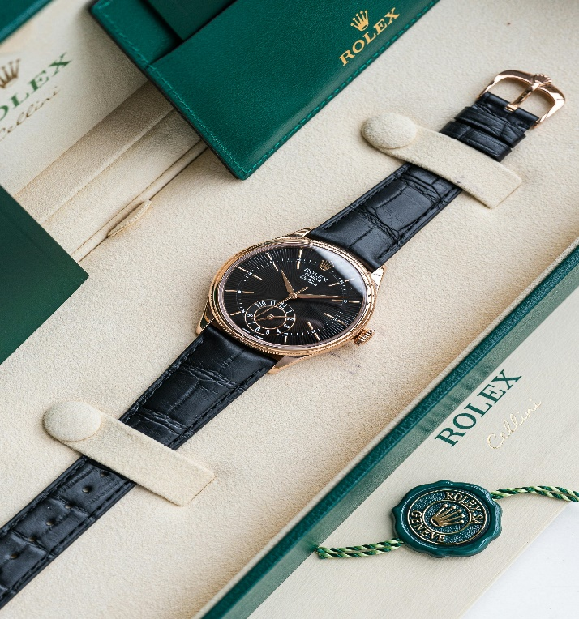

Quang Viet Nguyen 4

The Rolex Daytona, first released in 1963, was built for professional racers, featuring a water-resistant Oyster case, a tachymetric scale, and the Valjou 72 movement. It became a cultural icon in the 1970s when Paul Newman popularized it—his personal 6239 even sold for an incredible $17.8 million in 2017. Today, models like the 116500LN come with a tough Cerachrom bezel and Rolex’s high-tech Caliber 4130 movement. With its racing heritage, limited production, and status as a collector’s dream, the Daytona remains one of the most sought-after luxury watches in the world. (Rolex, 2024)

## Purpose

The main purpose is to drive the market even higher as there are few Agents and dealers here in South Africa, in the last year over 2% increase in value did markup go and this where I believe it will help the growth on (IPT) and bring in more publicity making it a well-rounded dealer in the country and boost the global trade markup in overall.

## Timeline

**Ironguard 2025 Strategic Plan for Luxury Watch Dealers and Sellers**

In the first and second quarters of 2025, finalize Irong-uard's brand identity, emphasizing our commitment to sustainability and authenticity.

Curate an exclusive collection featuring prestigious brands such as Audemars Piguet, Patek Philippe, and Rolex.

Establish partnerships with reputable retailers and collectors in key markets, including Dubai and London.

In the third and fourth quarters of 2025, introduce a limited edition of 500 highly coveted luxury watches, encompassing both rare and pre-owned pieces.

Launch our e-commerce platform, incorporating augmented reality for virtual try-ons and blockchain technology for authentication.

We aim to achieve a 70% sales rate of our new inventory within 48 hours following our inaugural exhibition at Watches & Wonders Geneva.

# Service Page

At Iron-guard Prestigious Timepiece We are dedicated to helping you discover the perfect watch, as we have a passion for fine timepieces. Our meticulously curated selection includes high-end, entry-level, and mid-range luxury watches from some of the most esteemed brands globally, catering to all levels of experience with luxury watches.

What we do?!

* Authentic Luxury Watches-We only offer premium timepieces that have been meticulously examined for quality and uniqueness. Our collection includes high-end brands like Patek Philippe, Omega, Rolex, and more, as well as timeless classics and uncommon rarities.
* Personalized Watch Consultation-Acquiring a luxury watch is more than just a straightforward purchase; it is an experience. Whether you seek a distinctive item, a prudent investment, or a timeless accessory for daily wear, our team is ready to assist you.
* Buy, Sell & Trade-Are you thinking about upgrading or selling your watch? We make the process easy for you. We offer fair and competitive prices for your timepiece, whether you wish to sell it for cash or trade it for a new model.

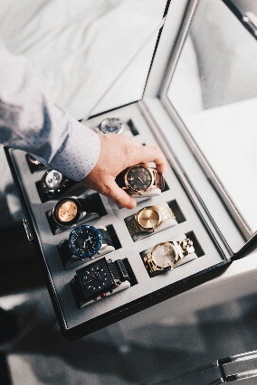

Mister Mister 5

Reasons to Choose Us

✔ Authentic timepieces that have undergone thorough verification.

✔ A friendly and relaxed service experience with expert assistance.

✔ Reliable, straightforward, and safe transaction processes.

✔ Secure and guaranteed international shipping.

Whether you are purchasing your first luxury watch or adding to your collection, we have everything you require. Feel free to reach out to us at any time!

## Our Goals and Objectives

Imagine yourself taking a study break at two in the morning, coffee in hand, as you explore our website and envision the watch you will buy when you secure your first significant job. We designed Iron-guard's website to serve as a supportive companion rather than a cold, polished catalog. It embodies the understanding that luxury transcends mere price tags; it encompasses the thrill of unboxing a long-awaited package and the quiet pride that accompanies owning something that truly reflects your identity.

Through the enhancement of our online visibility, the cultivation of trust, and the provision of a smooth purchasing process, we aim to position Ironguard as the leading choice for luxury timepieces. Alongside educating our clients and expressing our passion for exquisite watches, we will utilize SEO strategies, social media engagement, and informative content to attract watch aficionados, offer expert advice, and ensure that buying, selling, or trading is both straightforward and secure.

## How We Measure Success at Ironguard

At Ironguard, we assess our growth by focusing on several key objectives. As we expand into significant markets such as China and the UAE, we aim to uphold robust profit margins. It is essential for us to ensure that our stores operate at peak efficiency and that our limited-edition watches are sold out swiftly (Merien, 2021).

Enhancing customer loyalty is a priority; we expect a substantial portion of our revenue to derive from bespoke products, and we plan to leverage blockchain technology to foster trust. Additionally, we aspire to elevate our brand's visibility online and in the resale market through collaborations with influencers and unique offerings.

Sustainability is also a critical concern for us. Our objective is to shift towards solar-powered manufacturing and to incorporate more lab-grown gemstones. We believe that exclusivity, innovation, and accountability are fundamental to our success. (Twin, 2025)

# Contact Us

There will be a summary of the website and info, then followed by a closing message and heartfelt gratitude from the CEO of Iron-guard.

Our location information, this will contain the store address, physical location, street name and number.

Our phone information, this will have the contact details such as phone number, Tel number, where it will be easy to reach the business.

Our email information, the email address of the establishment, for any enquires, newsletters, blogs, this will consist of two emails- one for support teams, and two for Iron-guard Prestigious Timepiece.

# Bibliography

AG, T. s. (2025). Mission Statement,Vision,& Core Values (2025) of The Swatch Group AG.

Bain & Company’s Gen Z/Millennial luxury market projections 6(https://www.jewelsbylove.com/blog/post/watch-market-2025-outlook.html). (2025). Gen Z/Millennial luxury market projections 6. p. 6. Retrieved March 2025, from (https://www.jewelsbylove.com/blog/post/watch-market-2025-outlook.html).

CFI.CO. (2025, Jan 10). The Future of Luxury Watches: Trends, Players, and Market Insights for 2025. (C. f.-f. designs, Ed.) p. 11. Retrieved April 2025, from https://cfi.co/lifestyle/2025/01/the-future-of-luxury-watches-trends-players-and-market-insights-for-2025/.

Merien, M. (2021, Jul 16). What Are Key Performance Indicators in Retail? *MM*. Retrieved April 1, 2025, from https://www.simplifield.com/blog/what-are-key-performance-indicators-in-retail

Rolex. (2024, AUG). The Daytona a watch or Legend ? p. 2. Retrieved April 2025, from https://www.rolex.com/watches/cosmograph-daytona

Sotheby, P. a. (2025, March 31). Best Luxury Watch Brands To Invest In 2025 (Models & Prices. *Patek Philippe’s 5711/1A secondary market performance*, p. 4. Retrieved April 2025, from https://theluxuryplaybook.com/best-luxury-watch-brands/.

Twin, A. (2025, Jan 25). KPIs: What Are Key Performance Indicators? Types and Examples. *investopedia*. Retrieved April 3, 2025, from https://www.investopedia.com/terms/k/kpi.asp